**The digestion of chicken breast**

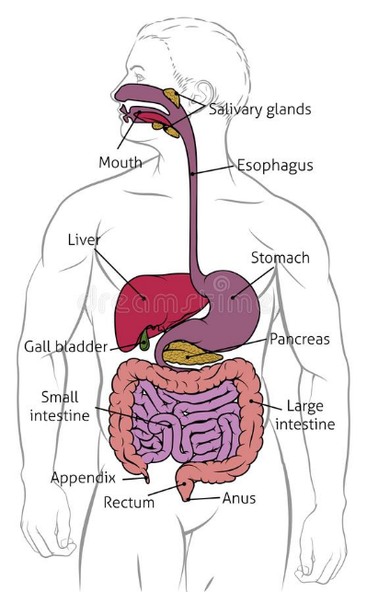**Mouth**

The digestion beings by entering the mouth. Mechanical digestion is used to break down the chicken breasts by the jaw’s movements causing the teeth to chew the food into a softer substance to futher digest. Saliva is secreted by the salivary glands at the back of the mouth containing enzymes.

**Esophagus**

When the chicken breast is finely chewed which can take up to 30 seconds to a minute dependent on the individual, the mixture of food and saliva, having formed a bolus, it then travels past the pharynx into the esophagus. The epiglottis is a movable lid located above the larynx which purpose is preventing food/drink from entering the windpipe. The process of peristalsis then begins contracting, squeezing the bolus down through the esophagus. This process takes a quick 6-12 seconds to reach the stomach.

**Stomach**

The stomach used two processes to further break down food for digestion such as mechanical digestion and chemical digestion. The stomach uses it’s muscles to churn the chicken breast with mixtures of enzymes and hydrochloric acid called digestive fluid This is also a form of mechanical digestion to further breakdown the bread into smaller particles. An average 85g grams of chicken breast contains 128 calories, 26grams of protein, and 2.7grams of fat. Pepsin the main digestive enzyme in the stomach breaks down the chicken breasts protein to become amino acids. The amino acids are then absorbed into the body by the bloodstream. Chicken breast takes between 2-6 hours to fully digest in the stomach and small intestine depending on the individual’s digestive health.

**Small intestine**

The bolus enters the small intestine by the duodenum, Pancreatic enzymes such as lipase, protease and amylase secreting the chicken breast into the small intestine. Protease breaks down protein in the intestines. The fat breaks down into fatty acids by the bile. By now the chicken breast is very digested turning it into a thick watery substance where it moves further down the small intestine into the jejunum where nutrients and water are fully absorbed.

P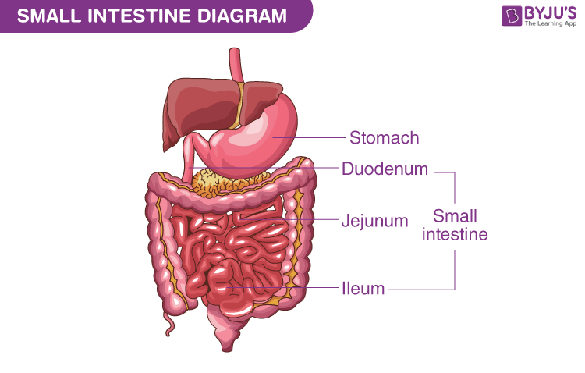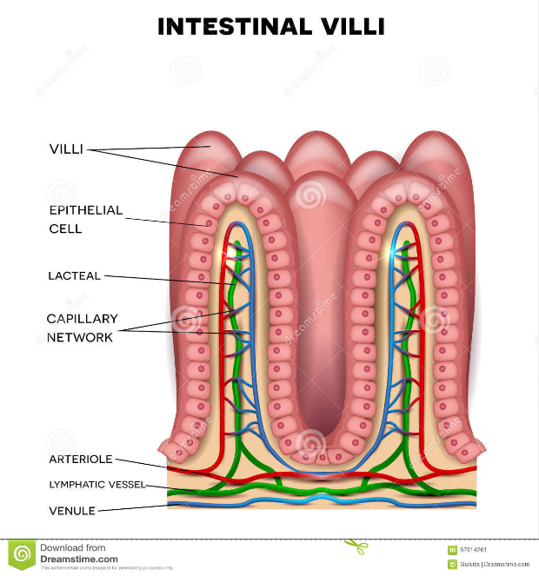

**Absorption**

Absorption is the final stage in digestion, where proteins becomes amino acids, and the fat becomes fatty acids and glycerol. Absorption happens in the mucosa, which is covered in villi. Villi contains tiny blood vessels which function is to increase surface area for absorption by extending the hair like ends. After nutrients are absorbed into the bloodstream by the villi and microvilli. Fatty acids are absorbed by simple diffusion. Then all the nutrients travel into capillaries to enter the bloodstream where nutrients are distributed around the body. Any substances that are not absorbed in the small intestine pass into the large intestine.

**Nutrition uses**

Nutrients from the blood stream are distributed to perform different functions. Amino acids undergo protein synthesis where they become usable protein. Which is essential to keep cells functioning and growth and repair. The fatty acids become stored fat into the body which can be used for energy during long durations of exercise.

**Large intestine**

Any excessive materials from the small intestine travel to the large intestine. Most of the water will become absorbed leaving just the hard waste called faeces. This is stored in the body for an average 30-40 hours before going through excretion where it is eliminated through the anus.

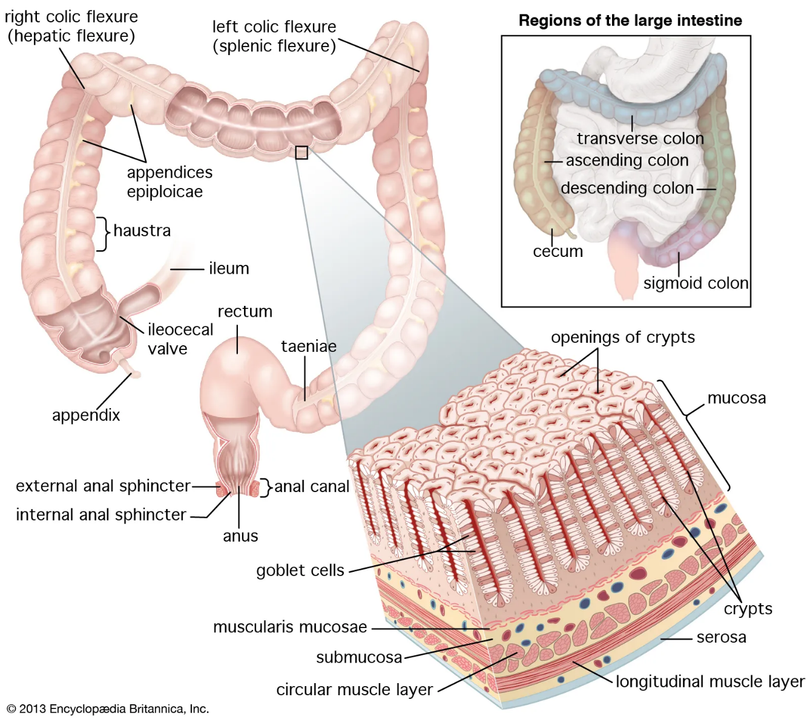

Bilblography

Overview of digestive system

Dreamstime, April 23 2019, <https://www.dreamstime.com/digestive-system-human-anatomy-gut-gastrointestinal-tract-diagram-human-digestive-gastrointestinal-tract-diagram-image145540067>

Small Intestine Diagram

BYJUS, August 25 2022, <https://byjus.com/biology/small-intestine-diagram/>

Intestinal villi anatomy stock

Dreamstime, March 9 2016, https://www.dreamstime.com/stock-illustration-intestinal-villi-anatomy-small-intestine-lining-epithelial-cells-microvilli-detailed-illustration-image67914261

Large Intestine

Encyclopedia Britannica, March 11 2023, https://www.britannica.com/science/large-intestine

Chicken breast nutrition facts

Malia Fret, September 22 2022, https://www.verywellfit.com/how-many-calories-in-chicken-breast-3495665#:~:text=One%203%2Dounce%20(85g),much%20larger%20than%203%20ounces.

How long does it take to digest chicken?

Tom Valenti, March 25 2023, https://oxbowtavern.com/blog/how-long-does-it-take-to-digest-chicken/#:~:text=FAQs-,How%20Long%20Does%20Chicken%20Stay%20in%20your%20Stomach%3F,absorption%20of%20nutrients%20take%20place.